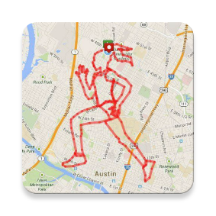

Runcture

A GPS Drawing Assistant

XU YAOHAI 53546028

CHEN HAOYUAN 53063079

WANG HAOYIN 53545289

CS4295 Assignment 2

Introduction

The Runcture is an Android Application development by our group. The APP aims to make GPS draw activity easier and more accurate. In this report, we will illustrate the background, APP flow, sell points, major challenges, potential improvement and self-reflection of Runcture.

Background

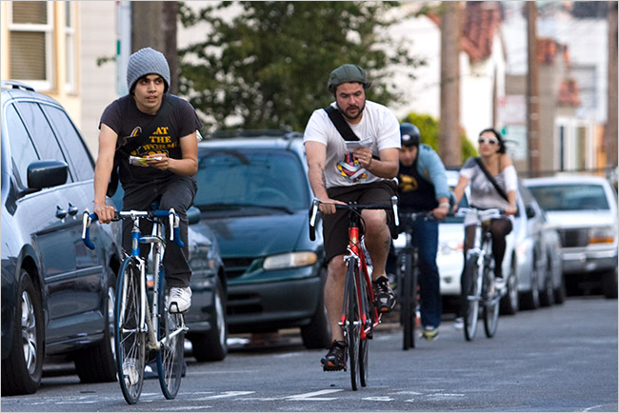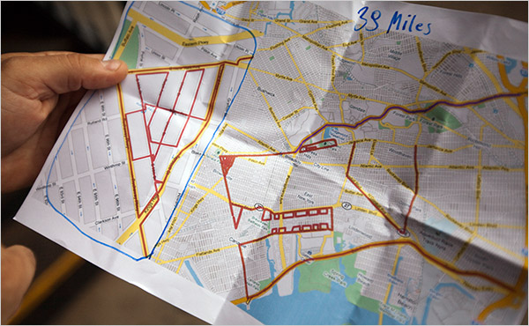GPS Drawing combines art, travelling (walking, flying and driving) and technology, and is a method of drawing that uses GPS to create large-scale artwork. GPS Drawing activity is become increasingly popular. People tend to do this activity to promote their ideas and advertise organizations. However, GPS Drawing is kind of difficult since the participators have to keep moving and at the same time keep themselves on the route. The typical way they do is to look at the map and find the route by their own imagination. It is difficult and extremely easy to make mistakes. The navigation apps like Google map can only help find the route between two points and the user do not have the freedom to design their own route. In the APP store there is no such application that can assist GPS drawing. So we decide to make a mobile application specially assisting GPS drawing. So here Runcture born.

APP Workflow

When the app first lunched, user will see a loading page. After the loading page, the main menu will be showed. User can start new drawing by clicking new, view past image by clicking Past, view app information by click about and view the instruction of how to use the APP by clicking Help.

After clicking new, user will enter Google map activity. In this activity, there are Google map API fragment and two buttons. When click the first button, a popup window will appear to let user input the address of their desire location. If the address isn’t exist, a popup alert will appear tell the user it is an invalid input. By input the address and direct operation on Google Map, user should make their desire drawing area center at the screen. Then user can click the second button to confirm.

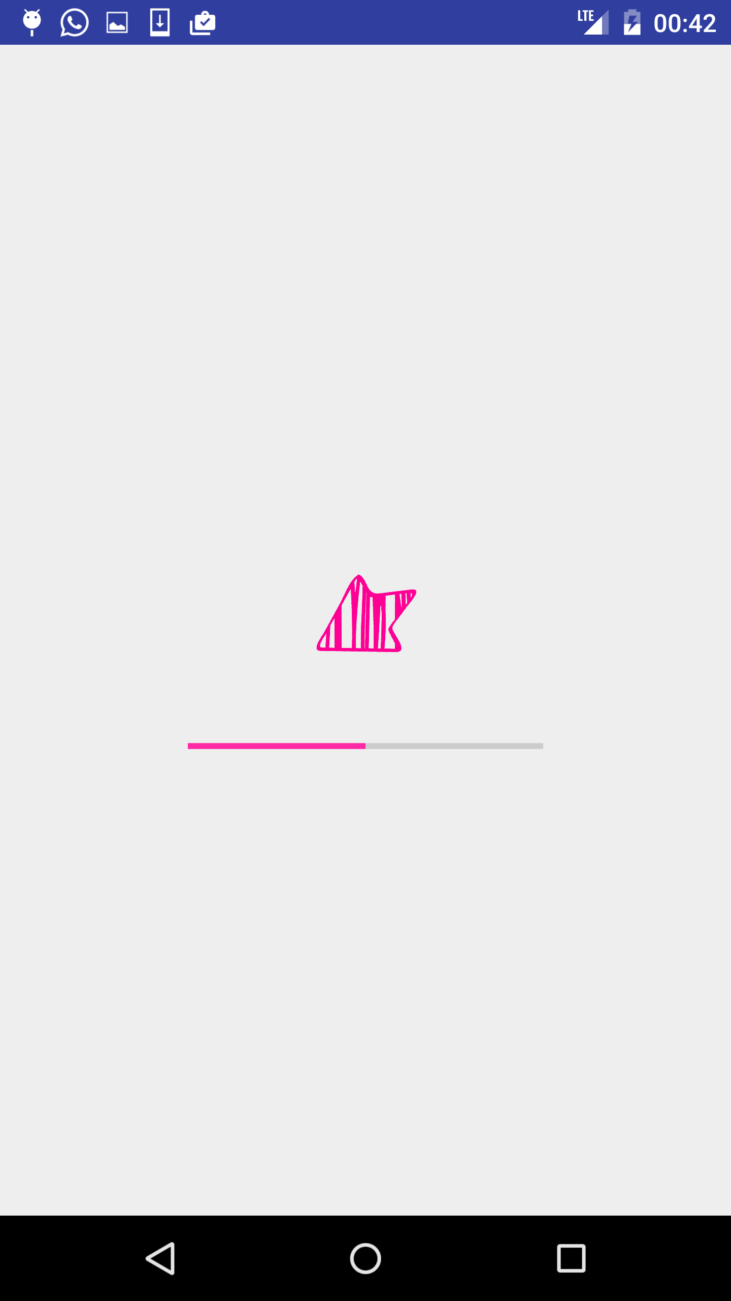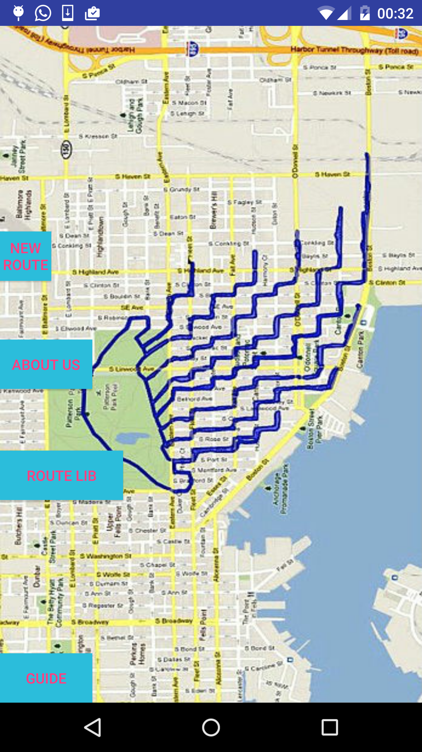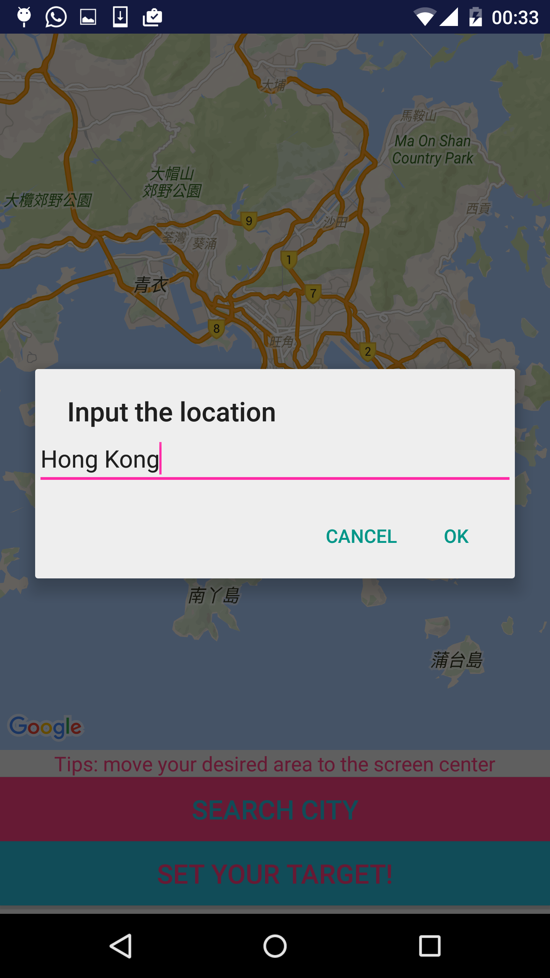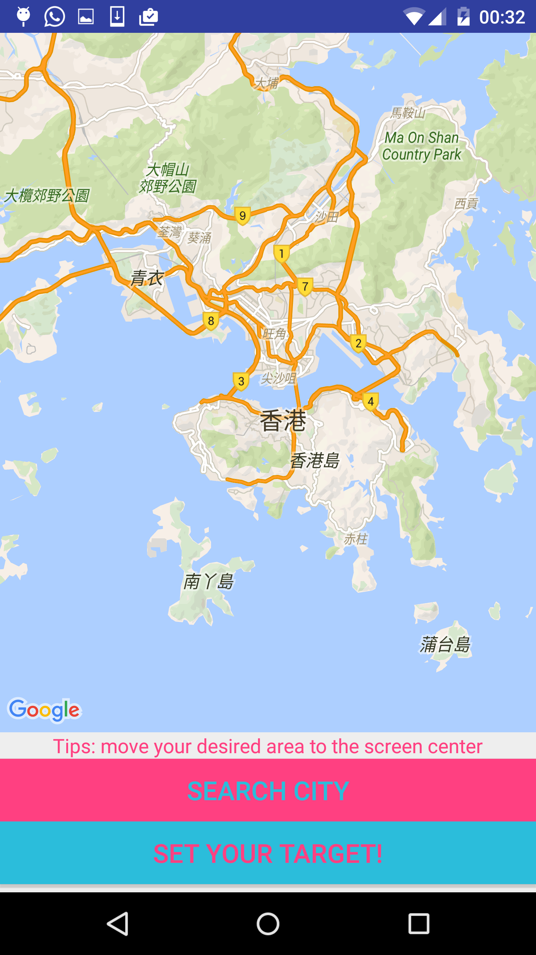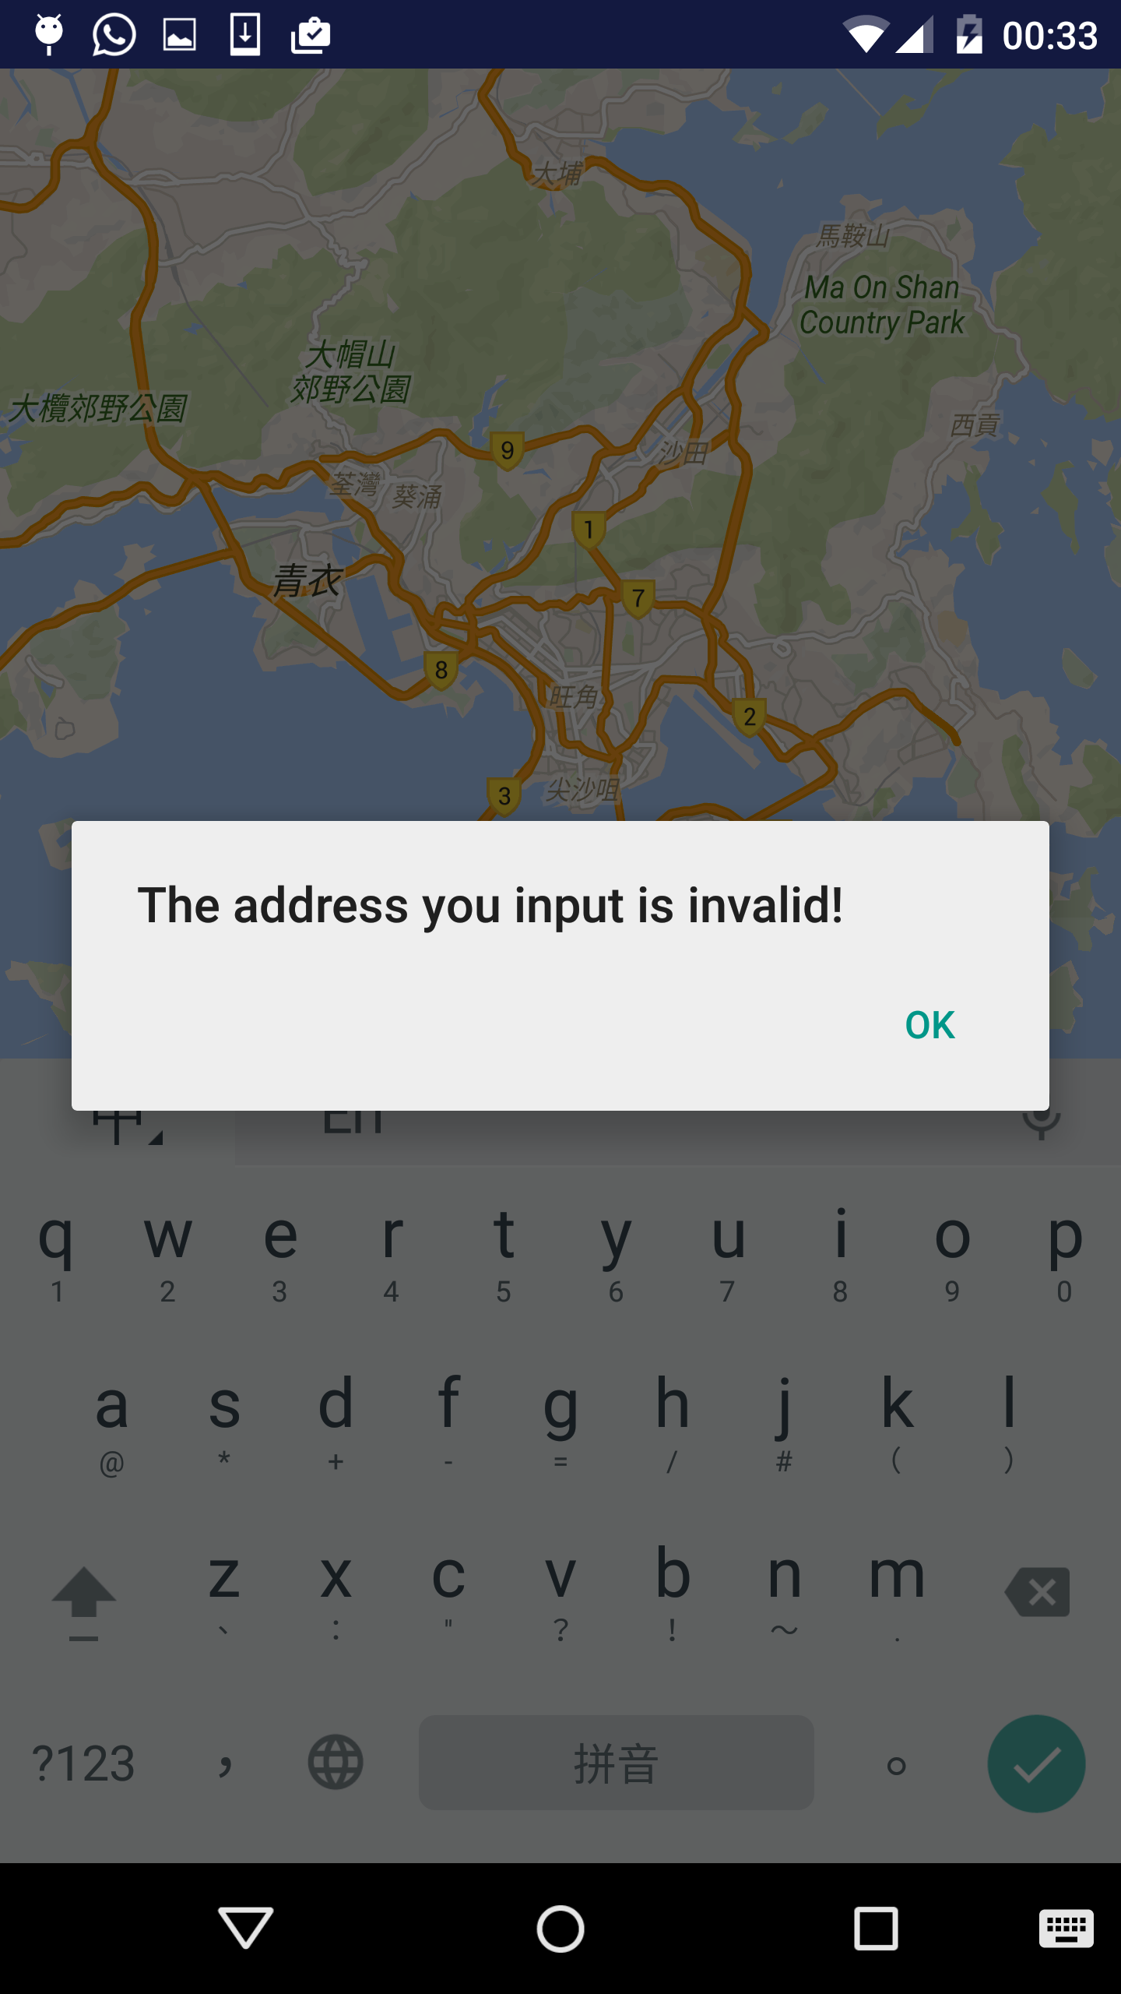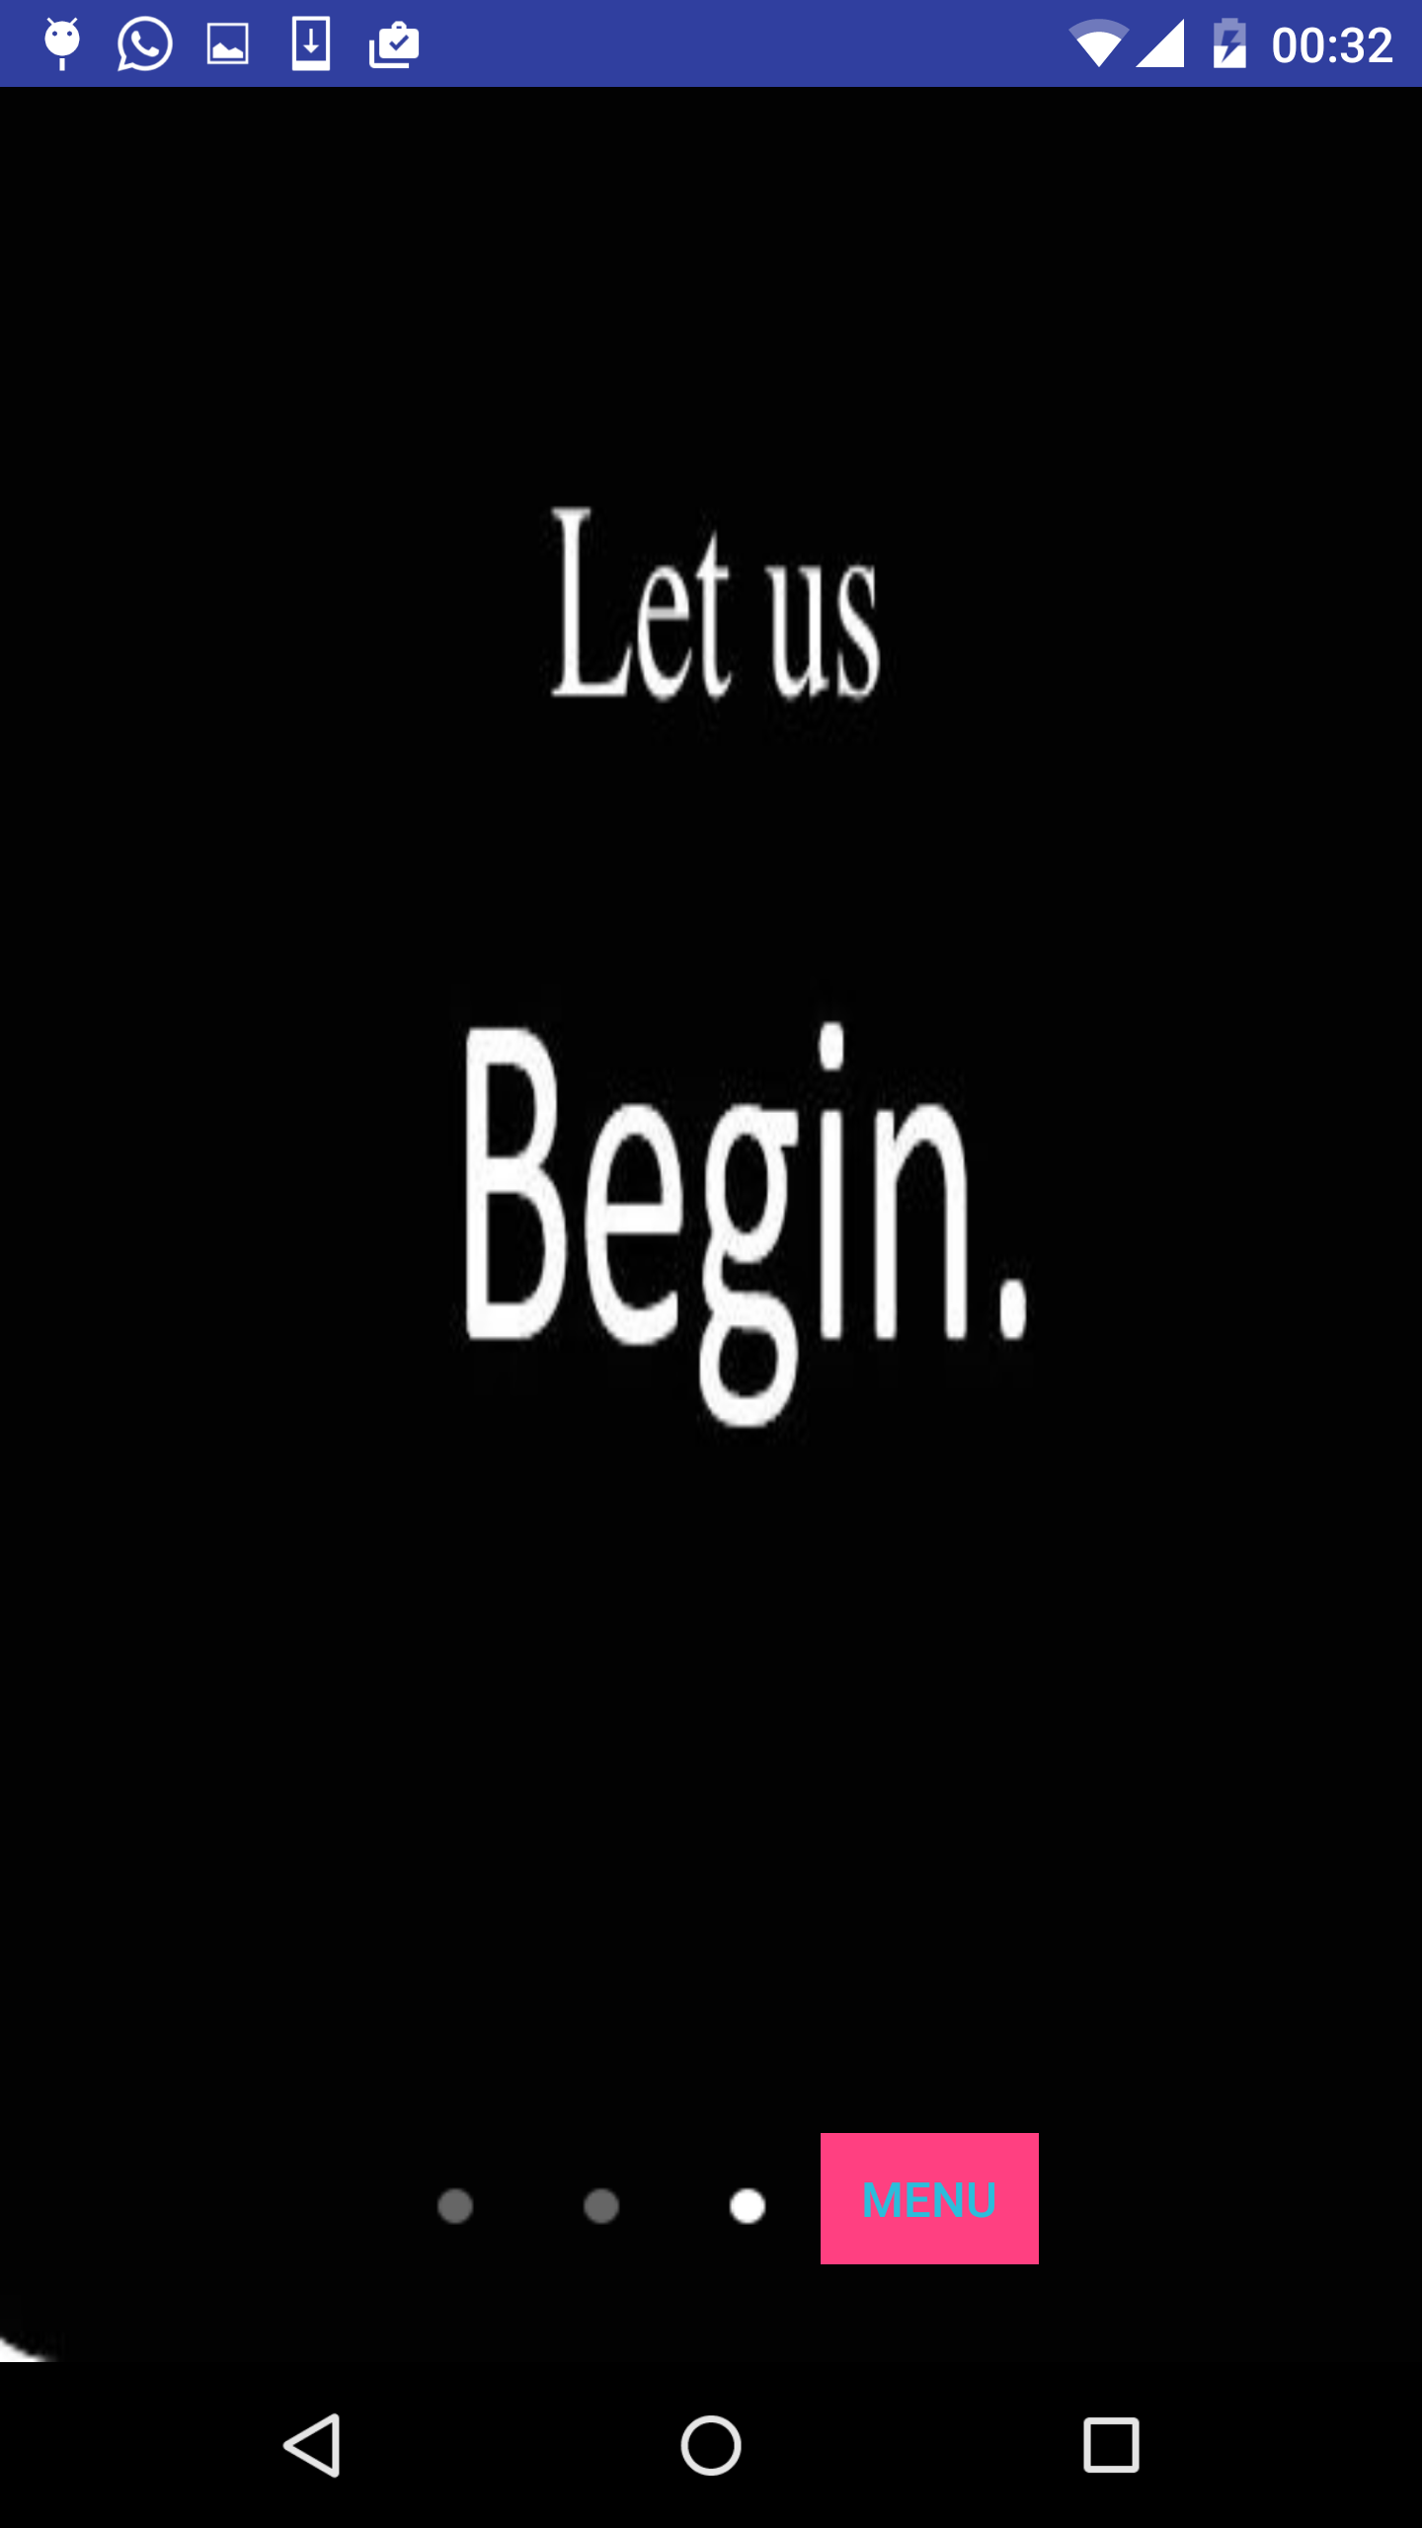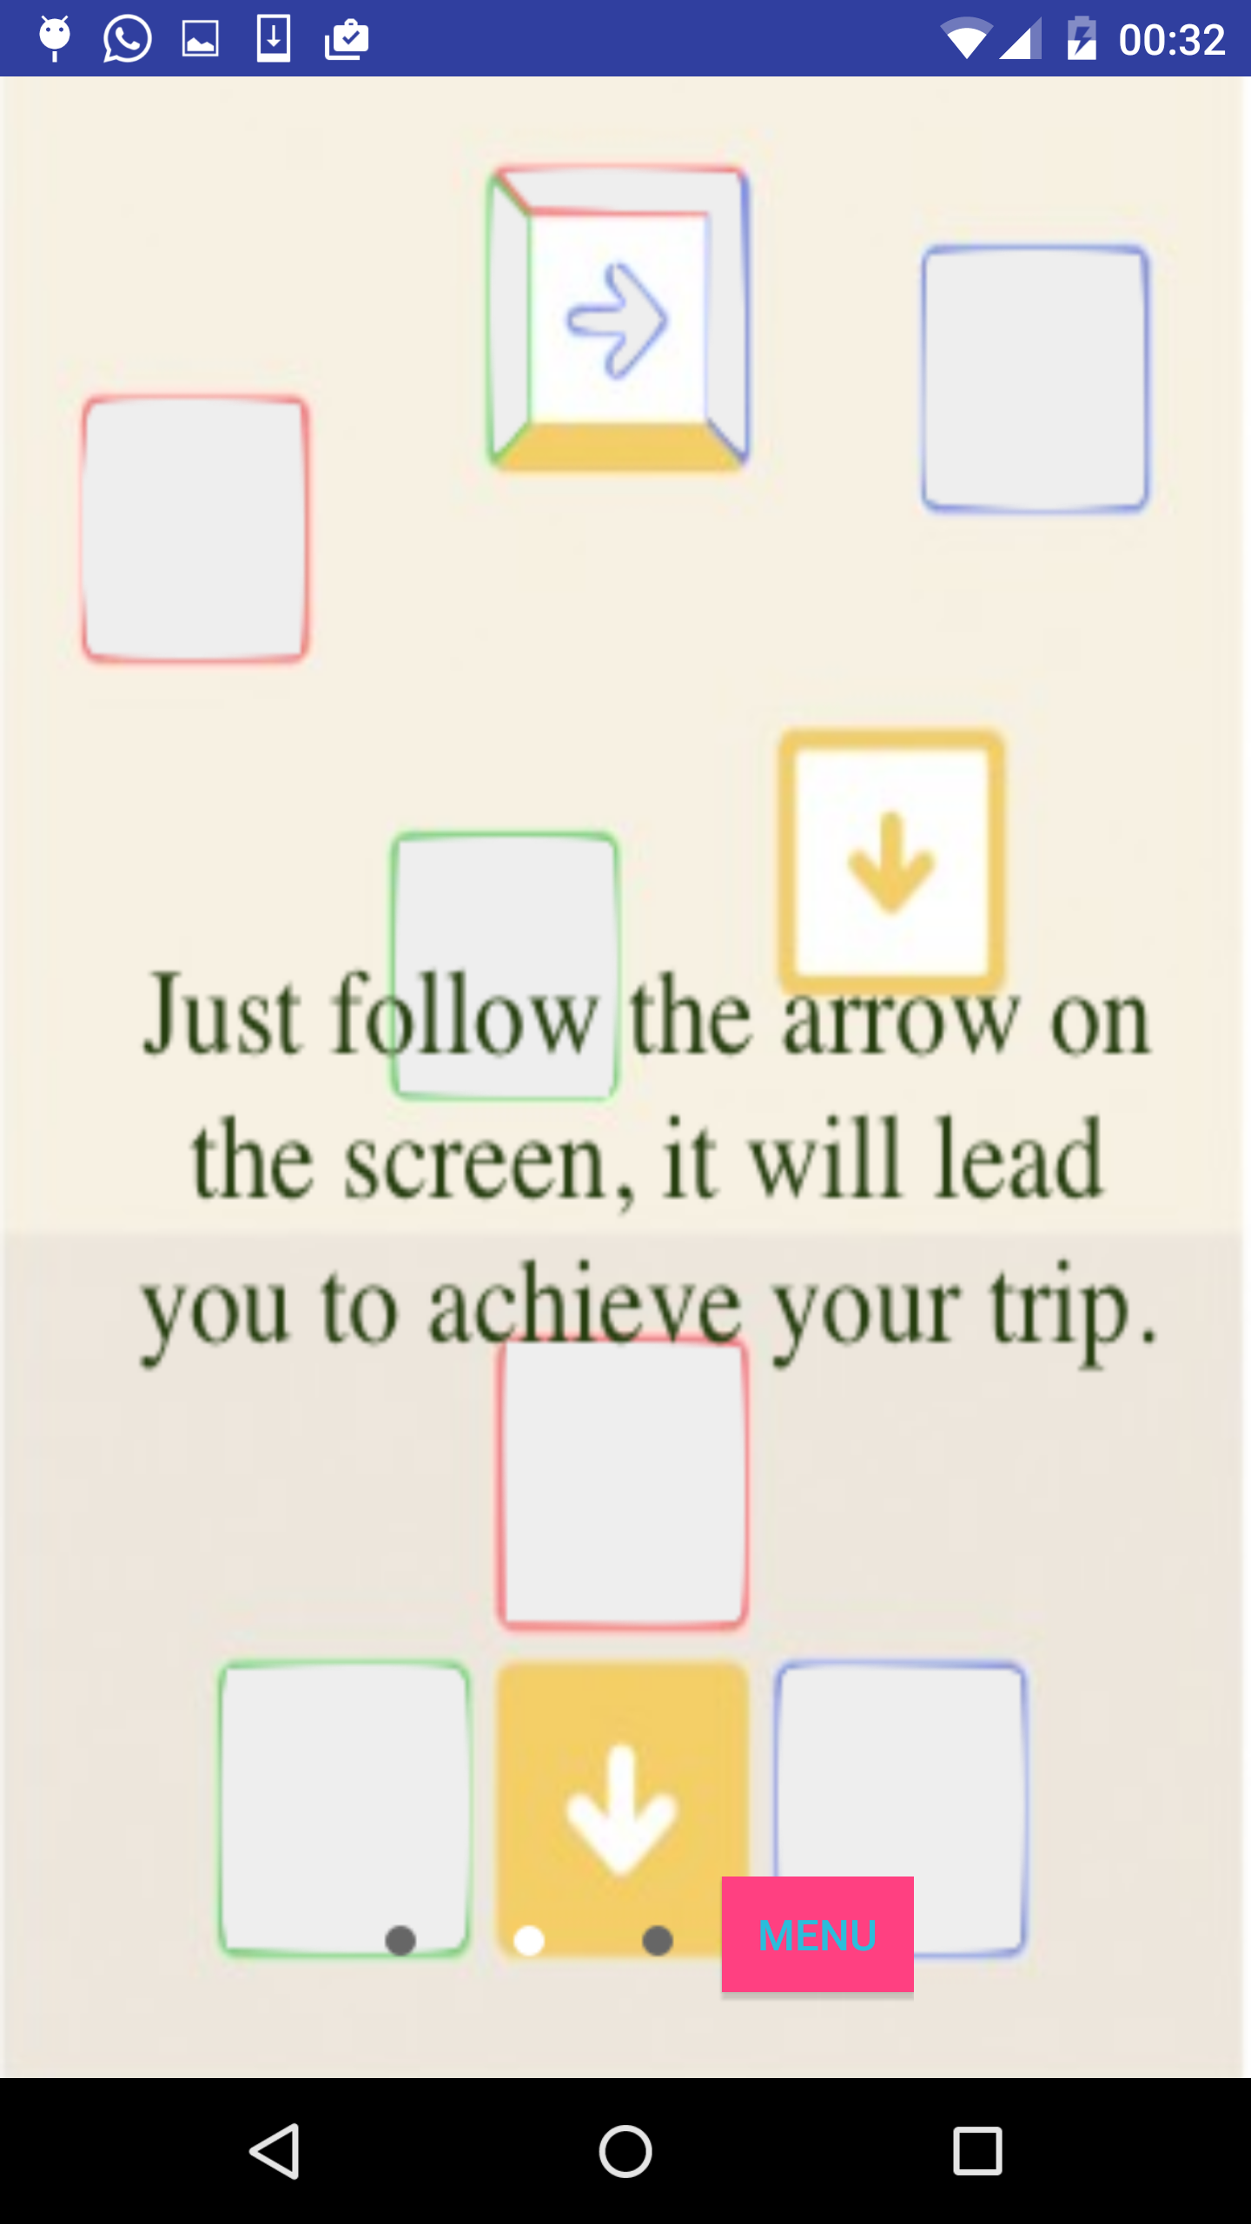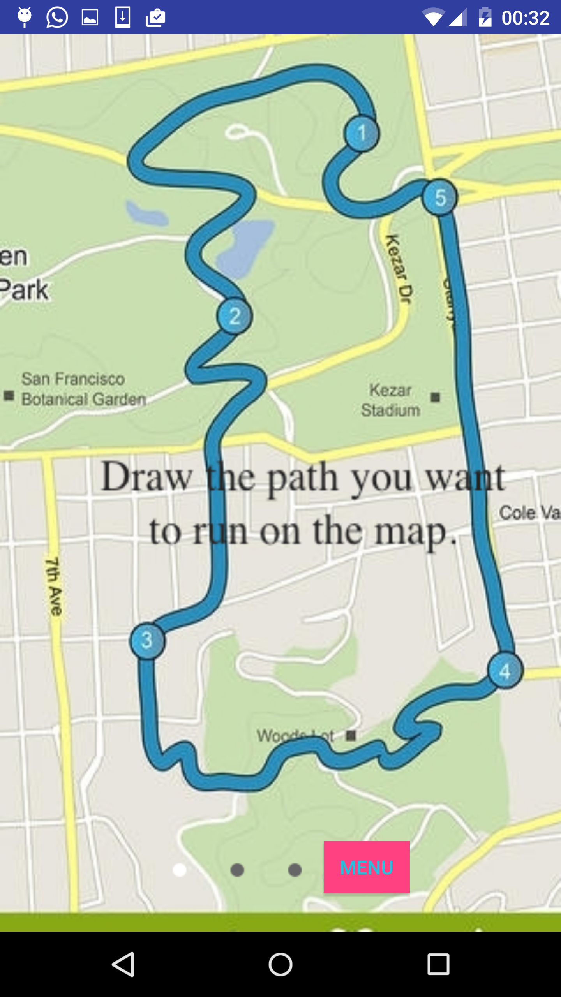

After the confirmation, APP will change to Drawing activity. There is a canvas with the selected location image on it. Below there are several opinions to let user change the property of the drawing brush including the color and thickness. User can draw their desire shape onto the map. If the user changed his mind, he can click reset to remove all the lines. If users confirm the drawing, he can click confirm.

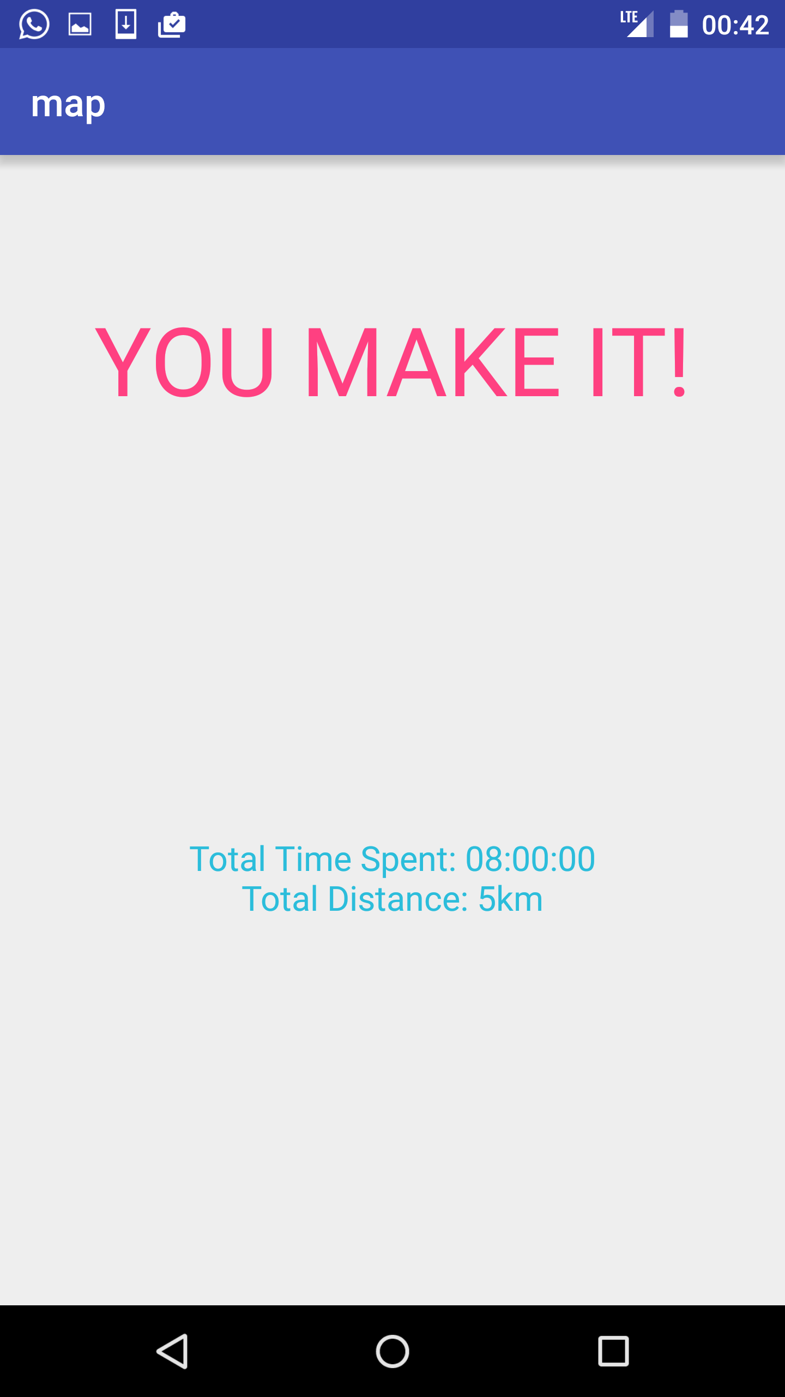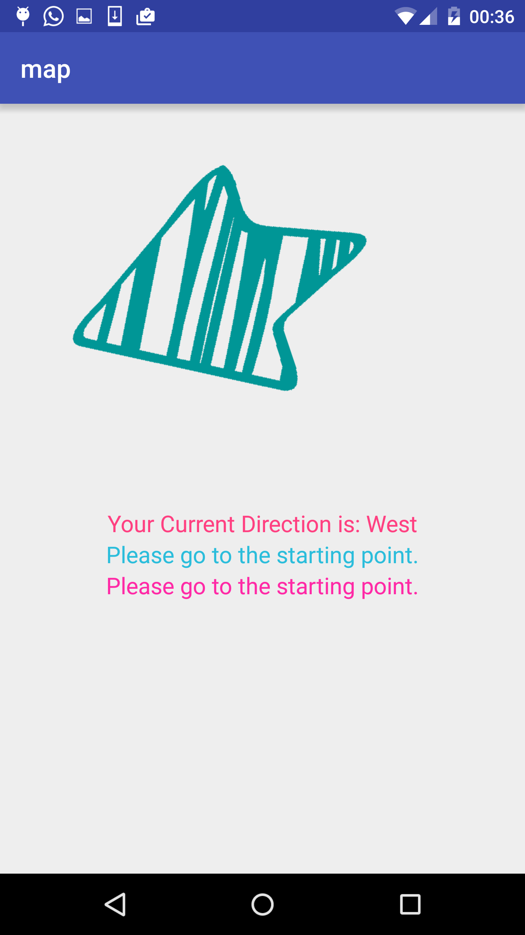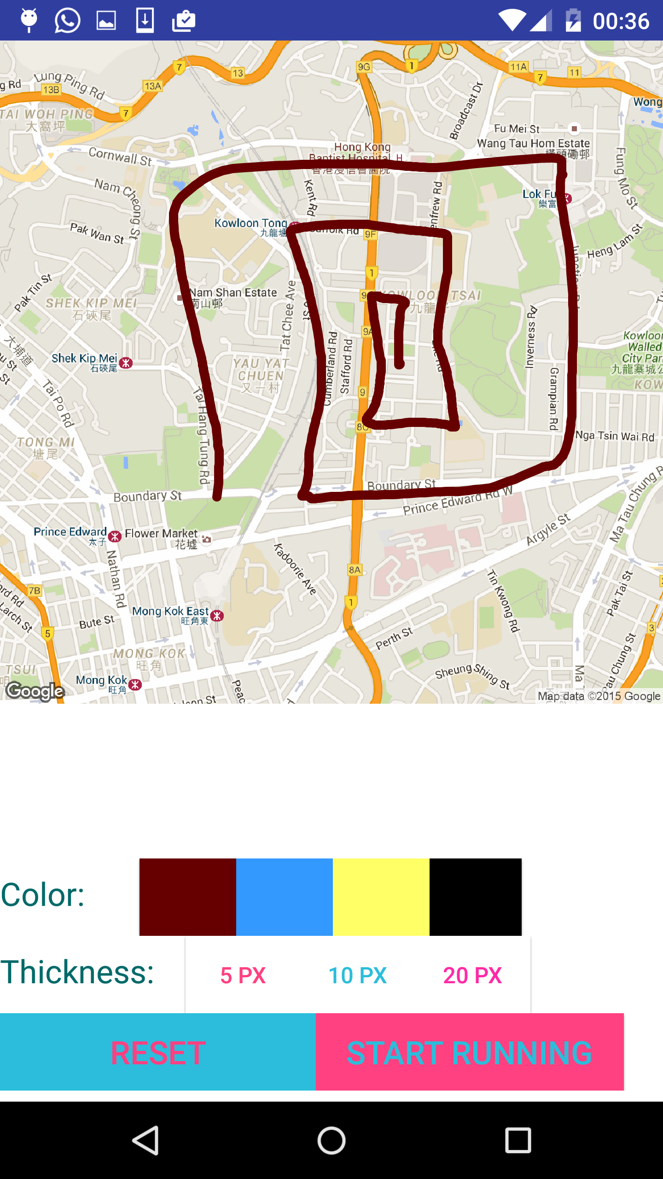

After user clicking confirm, the APP will lunch the guiding activity. In this activity, user will see an arrow. At first the arrow will point to your start point. Walking towards the arrow’s direction, user will get to the start point. Keeping following the arrow, user will do the GPS drawing. Below the arrow, there are lines of information telling user the percentage of route finished and how far the next check point is. When user reach the destination, a congratulation activity will show and telling the user the time user used and distance user drew.

Similar Apps

Runkeeper

Runkeeper is the most frequently used app when talking about run tracking apps. Unlike the app developed by our group, it focus more on tracking runners’ routes and calculating relational fitness-data to help runners achieve certain goals rather than focusing on the pre-plan routes and final patterns achieved. It has many interesting and valuable features like calculating running pace, cycling speed, route distance, elevation and calorie burn in real time, audio updates, making training plans for beginners, playing music while running and celebrating progress with friends. Anyone can use Google account or Facebook account to sign in and has fun with it. It mainly has four activities – START, ME, FRIENDS and TRAINING. On the START activity, it has a map and some location information. Users can set route mode and a rough pattern they want to run. The ME activity will be the screen shows while running. It has small partitions to keep different records like DISTANCE, CURRENT PACE and HEARTBEAT RATE. On the FRIENDS activity, users can share their running records with friends and give some comments on other users’ records. On the TRAINING activity, users can manage their past running records. It is helpful to measure the past training plans and make new training plans. Runkeeper combines run tracking apps and social networking apps together to get a better user experience. The layout is simple but clear and comfortable.

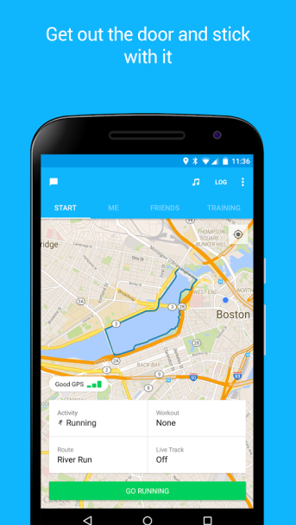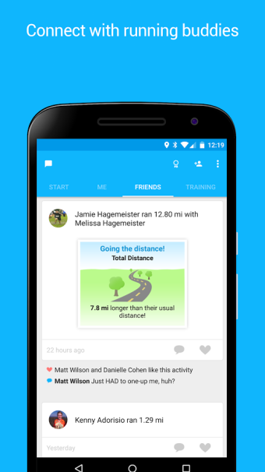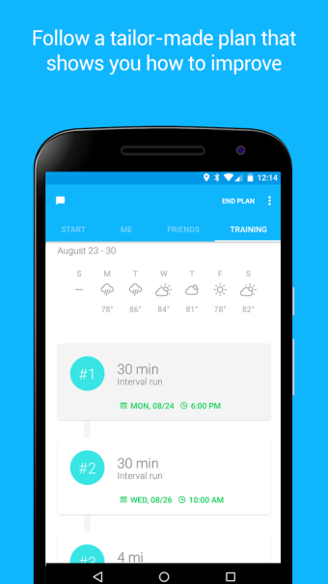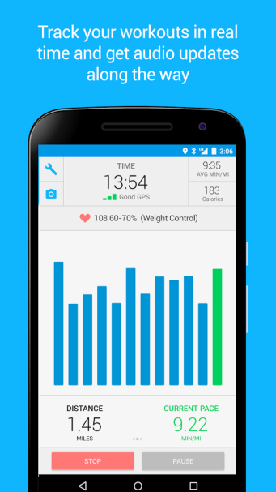

Scout GPS Navigation & Meet Up

Scout GPS Navigation & Meet Up is an app that allows users chatting, sharing ETAs and getting turn-by-turn GPS voice directions. It mainly has four activities. The first one is for users to instantly share their ETAs. It can let friends and family to know users’ current locations and the time they will spend on the traffic. The second activity is for users to choose routes. It maintains the total time needed and the detailed turn-by-turn directions for users to balance different routes. The third one is the main navigation activity. It has turn-by-turn voice guides and it also has a night mode. The fourth one is for users to create meet-ups with friends. Scout GPS Navigation & Meet Up combines navigation apps and social networking apps together to make users easier to manage their plans. The main difference between this app and our app is that it navigates based 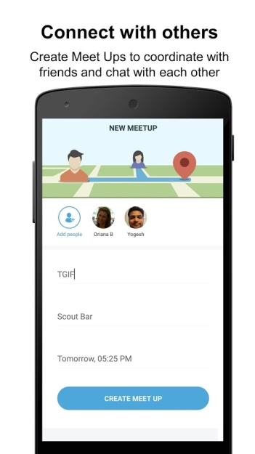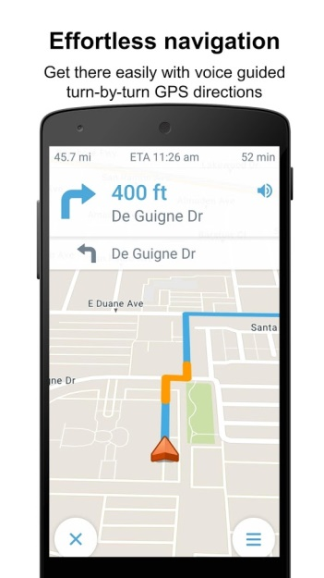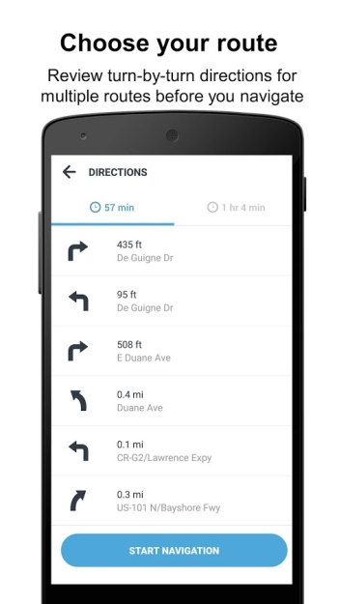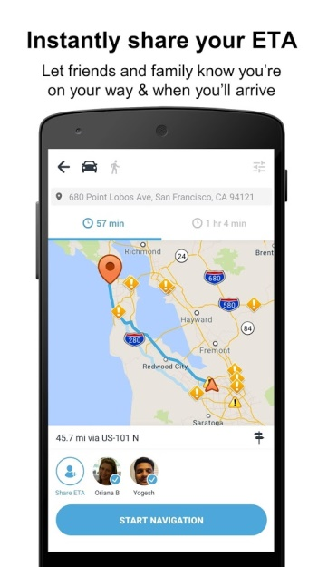on the start points and destinations, but our app is based on the patterns.

Infinite Painter

Infinite Painter is an excellent painting app that provides more than 80 brushes and self-defined brushed features. It is used by designers to create impressed designs. The main difference between Infinite Painter and our app is that our app only provides a few thickness options and color options for users to choose.

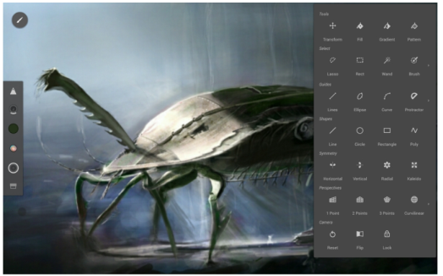

Selling Points

Our app mainly has two selling points:

1. Allow Users Pre-planning the Patterns

There exists many run tracking apps in the market, but the point is that they just record the trace. If users want to run a unique pattern like a triangle, a dog or a character, they need to draw on the paper-map, search for each road they will go through. It is clearly that this is a time-consuming task. If users use our app, they can forget about finding paths by themselves. They can draw the unique pattern they want to run by touching the screen, our app will record the pattern and do the route arrangements in background. It is not only saving time, but also let users more enjoyable in the running instead of afraid of the preparing works.

1. No more Maps, just Follow the Arrow

Most of the navigation app will show the roadmap to give a reference for users. For driving and visiting a unique destination, this is good. But if the user is running, the complicated map will not help a lot. So our app only uses a black background and an arrow as the navigation activity. There are no more maps, and the users only need to follow the arrow to turn left, turn right or just go straight. Our app is more practical when just used for running.

Challenges

1. Find place by address string

In order to assist the user to find the location quickly. We add a function to enable user to type in the address string of location to speed up the area selection process. We use the Geocode library to convert the address string to the latitude and longitude. Then let Google map API to move the creamer to the user input location.

1. Pass the bitmap between activities

At the first activity, the user choose the area and then the APP will download the static map image. The static map image need to be passed to the next activity for user to draw. So how to pass the image because a problem. At first, we tried to use the intent to pass the bitmap. However, the bitmap is way too large for intend to operate. Then, we decided to use the internal storage. At the first activity, we store the image in the internal storage and put the path of the image into intent. In the second activity, onCreate function get the path from intent and use the path to retrieve the map image.

1. Find accurate map image for drawing

User can use the Google Map API to find the area they intended to draw the route. But it is not possible to draw directly on the Google Map API. So after user choose the area, we need to generate an image of the area so the user can draw on the stable image. At first we considered to make a screen shot of Google Map so that user can get the exact same image of the map they saw on the Google Map API. However, this approach has an essential disadvantage that make us discard it. We cannot get accurate GPS information from the screen shot. Indeed using the API, we can get the latitude and longitude of the center point as well as the zoom level of the map, but the screen size and resolution varies on different devices and even the latitude, longitude and zoom level are the same, on different device, the map would be different. Without the knowledge of the resolution and screen size, we are not able to calculate the accurate route information in the next activity. Because of that, we decided to use the google static map. We would get the center point’s latitude and longitude and zoom level of the API as parameters for the request of static map. We also set the resolution as 640 x 640 which is the highest we can request from the Google. Since the parameter of the resolution is constant, we can accurately calculate the GPS information of each pixel points on the static map. This approach also have a disadvantage that is the image user saw in the API would be slightly different from the static map image. However, making the route guiding accurate is the first propriety so we finally chose to use Google static map.

1. Do the drawing (including changing thickness and color)

In the second activity, we used Canvas to implement the drawing function. In every onDraw function, the canvas would draw the static map image from last activity. Each touch event would invoke the lineTo function to do the drawing. We also put a reset button, so if the user made a mistake, he or she can clear all the route as well as delete all the route points stored in the arraylist. In order to let the user have more choices during the drawing, we also added buttons with different colors. So user can chose the colors they like to draw. Different levels of thickness can also be chosen so user can drawing exquisite route using thin lines. To realize the change of draw style, we implement some setter function to enable the button click event to change the value the canvas draw property.

1. Save the route

In order to pass accurate route information to the next activity, we have to figure out a way to store the drawing information.What we do is, for each touch event, we store the coordination of the touch point against the map image. All the pixel coordination pairs will be stored in an array list. So in the next activity, using these points, the route can be recovered.

1. Convert pixel coordination to latitude and longitude
   1. Situation

When the user is drawing their desire route on the map, the activity will record each touch events’ coordination against the canvas in pixel. However, how to convert the coordination to latitude and longitude for next activity use become a problem. As we know, the actual length of one degree of latitude varies as the longitude change. So we cannot simply use a scale percentage to solve the problem.

* 1. Solution

We used Mercator projection and some calculation to solve the problem.

Firstly the map image we have is get from the google static map. We can get the latitude and longitude of center point, the resolution of the image, zoom level and the scale size. To accommodate the various sizes of screens, we stretch the image to make it as wide as screen. (The maximum resolution we can get from static map is 640 x 640, the image usually need to be scaled up). The ratio of the stretch is recorded. Using the zoom level, scale size, stretch ratio and resolution of the map image, we can calculate the coordination of the corners of the map using Mercator projection. Using the coordination of corner, we can find out how much latitude and longitude each pixel represent in this map. Using the “pixel to latitude and longitude”, we can calculate the GPS coordination of each point of the route.

* 1. Limitation:

The Mercator projection indicates the length of one degree of latitude varies with the longitude, but in our conversion, each map image’s “pixel to latitude” ratio is constant. It won’t make observable skewing of the route in small scale. However, in larger scale, let’s say if the map contains a whole country (which is not this app’s target) the skewing would be significant. The larger the scale of the map, the less accurate the conversion is, which might be improved by using a better algorithm in the future.

1. Detecting the motion and rotation of the device

There are some challenges in implementing the function of detecting the rotation and motion of the device. The first one is the methods of detections, the second one is the noise of the data and the third one is the calibration of the sensor.

As for the first challenge, I was about to have the sensor manager call ‘getDefaultSensor(TYPE_ORIENTATION)’. Unfortunately, ‘TYPE_ORIENTATION’ was deprecated since the API level 20. As my goal is to detect the azimuth of the device (which direction the device is pointing to, north, east, west or south), there only two ways left. The first one is to have the sensor manager call the ‘getDefaultSensor(TYPE_ROTATION_VECTOR)’ and the second one is to call the ‘getDefaultSensor(TYPE_ACCELEROMETER)’ and the ‘getDefaultSensor(TYPE_MAGNETIC_FIELD)’, and I chose the latter one. To be honest, comparing to the old method, these two methods are more complicated to use and understand. It should go through two steps before we get the result we want. The first step is to obtain the raw data that the sensors get. Usually this data is represented in vector or matrix. The next step is to call another method to turn the raw data into the value indicating the angles the device rotates about the X, Y, Z-axis in the three dimensional space. The most challenging part is to understand what each number within the matrix is describing and through what computations the final result can be derived from the matrix. And I still has not figured it out by now.

As for the noise of the data, it is a problem but it does not really affect the outcome we want. The problem that truly matter is about the calibration. As a common issue among the navigator app, the sensor is not able to provide a correct direction information after repeated use. It may due to the interference in the magnetic field or the cache data that has not been cleared in the device. Currently, there is still no embedded code to help the sensor calibrate automatically.

1. The challenge in obtaining the location.

Apart from the challenge in coping with the sensor to detect the motion and rotation, there are also challenges lying in retrieving the device’s location. The first one is about the location provider. As the quality of the information provided by different providers may vary at different time. Not only the device should choose the best provider at the beginning but also should know to switch to another provider for more accurate location during the trip. The second challenge is how to decide the accuracy of the data obtained, especially in determining whether the user holding the device has reached the destination. A reasonable range should be set that once the user enter the circle centered by the exact coordinate of the destination, he/she should be acknowledged as ‘arrived’.

Future Improvement

For the future improvement, the application can be integrated with the OpenStreetMap API to retrieve the real world condition. What’s more, the camera can be also involved, such that the real world view is able to be captured and shown on the screen. Along with a three-dimensional navigating arrow, to provide a clearer vision to the users. It will enhance the quality of navigation and avoid the embarrassment that guiding the user to the blocked way.

1. Better UI

An interactive and attractive UI is essential for attracting users. We have sufficient back end but relatively poor user interface due to the development time constrain. So in the future development, we can make the UI better. For example, now our app has the basic layout and we can use ViewGroup, ViewPager, Toast, Spinner and other widgets to make more user-friendly interface future.

1. More accurate way to calculate the GPS coordination

As we illustrated before, we have a high accuracy in small scale map but lower in the larger scale. So finding a better approach to achieve both accuracy and efficiency is also important in future development.

1. Make route stick to road (type in character and convert it to route)

When making the route, our APP can only provide the function that let user draw the route by their finger move. We believe we should add more route making mode to this APP. For example, let user input the character by typing and the APP automatically draw the character onto the map and parse the GPS information of the route. The app can only assist GPS draw in open field like park. So taking one step further, ideally we want the map able to assist user to do the GPS draw on the road, or put in another way, to make the route draw by user stick to the road automatically. So user can do the GPS draw on the road and avoid impassable obstacle. However, realizing this function has a major difficultly, that is Google API didn’t provide function to help program recognize roads, which means the APP can only get the image of the map but not the road information of the map. So to realize this function, we need to crack the source code of Google Map API and even do the image pattern processing which is difficult to realize in a short period.

1. Eraser function in the drawing process

The drawing activity only provide a reset function to clear all the lines drew by the user. However, sometime, the user only make a tiny mistake and want to erase only small part of the lines. Realizing the partial erase on the canvas image is easy. However, the difficult point is how to change the array of points stored. Eliminate points in the middle of an array would cause route confusing and we cannot guarantee the order of the points of the array is correct if the user make a change in the middle of a route. We haven’t found a good way to realize the reestablishing of the order of points after partial change. So this is also a future improvement point.

1. Get access to the camera and use the street view as another location reference

Now our app use geolocations as the parameter to navigate. We can further use the camera to get real-time street views for a reference to make it more accurate.

1. Different user accounts

Now our app does not need user accounts to log-in. It is easy to use but it also decreases the changes to share past records will friends. We can create account for each user and combine the features of social networking apps with our features together. It will make this app more suitable on the market and it will let users make more fun.

1. Calibration

As one of the challenges mentioned above, functions should be explored to make the sensor calibrate automatically, or guide the users to do calibration.

1. Power consume

Currently the program is power-demanding since it simultaneously make use of the sensors and acquiring the location information. Ways to cut down the power wasted here might be tuning the delay and frequency that the sensors as well as the antenna request the data. Besides, some background processes should be maintained to keep monitoring the essential data change so as to allow the user to switch off the screen.

1. Navigate through street views or landmarks

Currently the whole navigation is based on the location and the direction, but neglecting the real world situation like the roads, buildings or other geographical environment. In In the future improvement, the application can be integrated with the OpenStreetMap API to retrieve the real world condition. What’s more, the camera can be also involved, such that the real world view is able to be captured and shown on the screen. Along with a three-dimensional navigating arrow, to provide a clearer vision to the users. It will enhance the quality of navigation and avoid the embarrassment that guiding the user to the blocked way.

Self-reflection:

CHEN Haoyuan

During the development, a bug took us around 3 hours to fix though at last it was discovered as a ‘stupid’ mistake made by us. It was related to the activity life cycle.

The problem was like this, no compilation error or runtime exception occurred, but the program hanged when it run to a specific stage, with the log read that ‘Skipped 300 frames, the main thread was doing too much work.’ At first we thought it was due to some tedious calculation of the sample points we collect, or the heavy-refreshing of the UI component (e.g. the TextView kept updating data or the ImageView’s animation was dead). Following some guide on the Internet, we tried to adopt a multi-threaded design, but still in vain. Eventually, we suspected a loop in the onStart() of one of the activities. So it was the loop that trapped the app. We once thought that the app should be staying in the onStart() or onResume() stage while it was running. This case made us alert and be aware of the concept and theory of Android programming.

During combining our teams work in different phases, we came across troubles due to un-matched API levels among us. As the resource files were generated in different style by different level of API, it cost us some time to fix the incompatibility among the files. It would be better if we had come to a consensus on the file path structure and besides, we can utilize some code-collaborating platform like Git-Bucket.

Although developing the location based service and the motion/rotation sensing is not tedious in coding. But you need to be familiar with their working features, or you will get trouble with them. The two major problems should be take extra consideration are the response time of the location provider and the accuracy of the motion/rotation sensor.

XU Yaohai

During the development process, I got familiar with Android programing, Google Map API, GPS projection, internal storage, Geocode library and Android canvas. I also learned to make costumed view and enables the intercommunication between the costumed view and activity. It is a productive learning experience.

Wang Haoyin

Responsible for the start activities of the app, I have used splash activity to act as a welcome screen. I use an array to simulate loading process and to make a progress bar. For the SwitchView activity, it is a guide of how to using our app. For this activity, I use a self-defined layout to achieve ViewGroup feature. I first want to use ViewPager to achieve the scrolling feature, but when I wrote it, Android Studio said that some methods like instantiateItem and destroyItem were not used any more so I could not override it. And I used VireGroup instead. It is more completed because I must define an interface OnViewChangeListener. Next is the main activity, it has three buttons, one for enter the drawing activity, one for accessing gallery of the phone and one for showing the information of our group. It uses alert dialog because I think using a toast is not very proper for this button. For the application, I used fullscreen theme to make a better interface.

Responsibility of Each Member

Wang Haoying (53545289): Loading Page, Menu Page, Guide Page

Peter XU Yaohai (53546028): Show Google Map Page, Draw on Google Map Page, Refactoring the code.

Tom CHEN Haoyuan (53063079): Navigation Page, Finish Page, Combining individual parts